Muriel SAFI  Avocat  EXPERTISES  - Corporate  - Litigation  - Energy  EXPERIENCE  Muriel received his law degree from the University of Brussels (U.L.B.) in 2002.  She devoted the next 5 years to her children and family.  In 2007, a first experience in the European Parliament led Muriel to work in matters relating to Environment (including climate change), Public Health and Consumer Protection (among ALDE Party “Alliance of liberals and democrats for Europe”).  Muriel has been admitted to the Brussels Bar since 2008.  She joined Lexlitis Brussels as a collaborator of Sylvain Silber in 2012 in legal matters such as Health Law, Energy Law, Contract law, Professional liability.  She has been a Mediator in Civil and Commercial Law since 2013. | 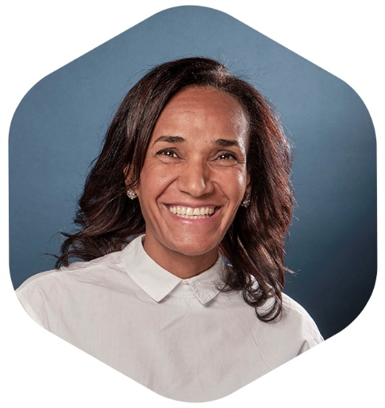  safi@lexlitis.eu  +32 2 379 24 72  +32 478 20 73 00  Dieweg, 274 - 1180 Bruxelles  FORMATION  Law degree  Diploma in Private Civil Law  (Main Property Rights)  Université Libre de Bruxelles (U.L.B.)  LANGUAGES  French (Native)  English (Good level)  Dutch (Good)  Spanish (Basic)

TRAININGS:

2013:
- Mediator in Civil and commercial law

January 2016:
- Business Mediation Summit : Challenge your Dispute Strategy

October 2017:
- The Protection of Personal data

December 2018:
- The New Code of Societies and Associations

October - december 2019:
- Special training in Legal English (Cases and Materials : Civil Procedure, Family Law, Law of Torts, Contract Law

2021-2023:
- Dutch lessons in V.U.B. (with CVO SEMPER)

September 2023 till March 2024:

- Lawyer Leader Manager (special training in Solvay Brussels School Economics & Management

Miscellaneous:
I.T.: Computer literate

Hobbies: Travels, Marathoner, Volunteering in social & youth activities, lover of the Arts.

